Face Recognition in unconstrained environment using Deep Learning

Project ID: 22301
B.Tech. Project Report
submitted for fulfillment of
the requirements for the
Degree of Bachelor of Technology
Under Biju Pattnaik University of Technology

Submitted By

Swapnadeep Samal ROLL NO. CSE201810384
Anisha Mohanta ROLL NO. CSE201843391


2021 – 2022

Under the guidance of
Prof. Pradeep Kumar Jena

NIST INSTITUTE OF SCIENCE & TECHNOLOGY (Autonomous)
Palur Hills, Berhampur, Odisha – 761008, India

Abstract
Deep Learning has been playing a significant role in solving Computer Vision problems. In most recent times, the Face Recognition technique is widely used in many automation systems, it has been one of the extensively. Facial recognition is a way of recognizing a human face through technology. The Conventional Facial Recognition system uses biometrics to map facial features from a photograph or video by comparing the information resides in the database to find a match. The significance of face recognition is due to its technical challenges and wide potential application in video surveillance, identity authentication, multimedia applications, home and office security, law enforcement and different human-computer interaction activities.
The rise of Deep learning has laid the path in solving a lot of problems in wide research areas, especially Convolutional Neural Networks (CNNs) have achieved significant success in the area of computer vision by providing efficient solutions through different architectures.
The project proposes a novel deep learning architecture for Face Recognition and a pipeline to develop an end-to-end facial recognition system which includes collecting real time data i.e., Human Faces, Pre-Processing, Model Training and Hyper Parameter Optimizations.

Table of Contents
Table of Figures 4
1. Introduction 5
1.1 Importance of Face Recognition 5
1.2 Problem Definition 5
1.3 Objective 5
2. About Deep Learning 6
2.1 Why Deep learning? 6
2.2 How Deep learning works? 7
2.3 Deep Convolution Neural Networks 7
3. Requirements 9
3.1 Python 9
3.2 Jupyter 9
3.3 TensorFlow 9
3.4 Keras 10
3.5 SciKit - Learn 10
3.6 Pandas 10
4. Data Collection and Analysis 11
4.1 Data Augmentation 11
5. Developing CNN Model 13
5.1 Role of CNN in Computer Vision 13
5.2 Essential layers to develop CNN 14
5.2.1 Convolution Layer 14
5.2.2 Batch Normalization Layer 15
5.2.3 Max Pooling layer 15
5.2.4 Drop-out Layer 16
6. Conclusion7. References 18

Table of Figures

Fig-1 - Neural networks, which are organized in layers consisting of a set of interconnected nodes. 7
Fig 2 - Dataset Collection 11
Fig 3 - Convolution layer 14
Fig 4 - Max Pooling Operations 16
Fig 5 - Operation of Drop out 17
Fig 6 - Fully Connected Layer 17

1. Introduction
Face recognition is one of the few biometric methods that possess the merits of both high accuracy and low intrusiveness. It has the accuracy of a physiological approach without being intrusive. For this reason, since the early 70's (Kelly, 1970), face recognition has drawn the attention of researchers in fields from security, psychology, and image processing, to computer vision. Numerous algorithms have been proposed for face recognition; for detailed survey please see Chellappa (1995) and Zhang (1997).

1.1 Importance of Face Recognition
Face Recognition generally measures the unique patterns of a person’s face by comparing and analyzing facial contours. It is not only used in security and law enforcement but also used as a way to authenticate identity and unlock devices like smartphones and laptops. Now-a-days, we are observing many smartphones and laptops having a face recognition system to unlock the device.

1.2 Problem Definition
This project is about developing a highly efficient face recognition framework to learn a robust face detection and verification in an unconstrained environment using aggressive data augmentation and convolutional neural networks. The objective is to learn a deep face representation from large-scale data with massive noisy and occluded face. This needs to add an adaptive fusion of softmax loss and center loss as supervision signals, which are helpful to improve the performance and to conduct the final classification.

1.3 Objective
To study and design a face detection and recognition framework that can detect and recognize faces in real time in an unconstrained environment.

2. About Deep Learning
Deep learning is a machine learning technique that teaches computers to do what comes naturally to humans: learn by example. Deep learning is a key technology behind driverless cars, enabling them to recognize a stop sign, or to distinguish a pedestrian from a lamppost. It is the key to voice control in consumer devices like phones, tablets, TVs, and hands-free speakers. Deep learning is getting lots of attention lately and for good reason. It’s achieving results that were not possible before.
In deep learning, a computer model learns to perform classification tasks directly from images, text, or sound. Deep learning models can achieve state-of-the-art accuracy, sometimes exceeding human-level performance. Models are trained by using a large set of labeled data and neural network architectures that contain many layers.

2.1 Why Deep learning?
Because of accuracy. Deep learning achieves recognition accuracy at higher levels than ever before. This helps consumer electronics meet user expectations, and it is crucial for safety-critical applications. Recent advances in deep learning have improved to the point where deep learning outperforms humans in some tasks like classifying objects in images.
While deep learning was first theorized in the 1980s, there are two main reasons it has only recently become useful:
- Deep learning requires large amounts of labeled data. For example, driverless car development requires millions of images and thousands of hours of video.
- Deep learning requires substantial computing power. High-performance GPUs have a parallel architecture that is efficient for deep learning. When combined with clusters or cloud computing, this enables development teams to reduce training time for a deep learning network from weeks to hours or less.

2.2 How Deep learning works?
Most deep learning methods use neural network architectures, which is why deep learning models are often referred to as deep neural networks. The term “deep” usually refers to the number of hidden layers in the neural network. Traditional neural networks only contain 2-3 hidden layers, while deep networks can have as many as 150. Deep learning models are trained by using large sets of labelled data and neural network architectures that learn features directly from the data without the need for manual feature extraction.
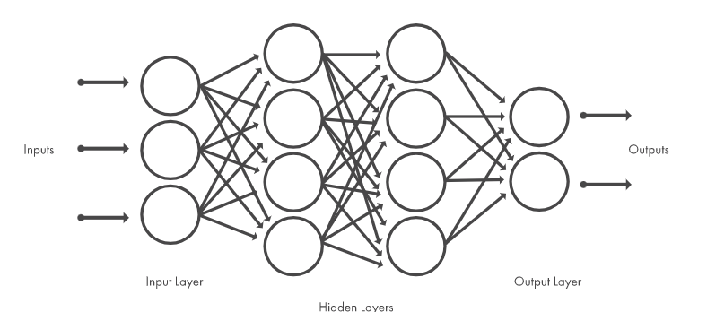
Fig-1 - Neural networks, which are organized in layers consisting of a set of interconnected nodes.

2.3 Deep Convolution Neural Networks
Deep Convolutional Neural Network (CNN) is a special type of Neural Networks, which has shown exemplary performance on several competitions related to Computer Vision and Image Processing. Some of the exciting application areas of CNN include Image Classification and Segmentation, Object Detection, Video Processing, Natural Language Processing, and Speech Recognition.
The powerful learning ability of deep CNN is primarily due to the use of multiple feature extraction stages that can automatically learn representations from the data. The availability of a large amount of data and improvement in the hardware technology has accelerated the research in CNNs, and recently interesting deep CNN architectures have been reported. Several inspiring ideas to bring advancements in CNNs have been explored, such as the use of different activation and loss functions, parameter optimization, regularization, and architectural innovations. However, the significant improvement in the representational capacity of the deep CNN is achieved through architectural innovations. Notably, the ideas of exploiting spatial and channel information, depth and width of architecture, and multi-path information processing have gained substantial attention. Similarly, the idea of using a block of layers as a structural unit is also gaining popularity.
CNNs are one of the best learning algorithms for understanding image content and have shown exemplary performance in image segmentation, classification, detection, and retrieval related tasks. CNN, with the automatic feature extraction ability, reduces the need for a separate feature extractor. During training, CNN learns through backpropagation algorithm, by regulating the change in weights according to the target. Optimization of an objective function using a backpropagation algorithm is similar to the response-based learning of the human brain. In 2015, the concept of skip connections introduced by ResNet for the training of deep CNNs gained popularity. Afterward, this concept was used by most of the succeeding networks, such as Inception-ResNet, Wide ResNet, ResNeXt, etc., CNN has not only shown good performance on images but also on 1D-data. The use of 1D-CNN as compared to other ML methods is becoming popular because of its good feature extraction ability. The major challenge with CNN is that deep CNNs are generally like a black box and thus may lack in interpretation and explanation. Therefore, sometimes it is difficult to verify them. Data augmentation can help CNN in learning diverse internal representations, which ultimately may lead to improved performance.
In simple words, a CNN is a deep neural network convolves learned features with input data, and uses 2D convolutional layers, making this architecture well suited to processing 2D data, such as images. The CNN works by extracting features directly from images. The relevant features are not pretrained; they are learned while the network trains on a collection of images. This automated feature extraction makes deep learning models highly accurate for computer vision tasks such as object classification. CNNs learn to detect different features of an image using tens or hundreds of hidden layers. Every hidden layer increases the complexity of the learned image features. For example, the first hidden layer could learn how to detect edges, and the last learns how to detect more complex shapes specifically catered to the shape of the object we are trying to recognize.

3. Requirements
It is essential to understand the requirements of the project which plays a crucial role in developing and achieving or meeting the desired goal. The requirements of the project for developing and reproducing the results of the projects are discussed in detail.
These are the essential requirements that are necessary to build and deploy the Deep learning model. The windows10 operation system with intel i7 9th processor having 8GB RAM is used and the installation on the programming language and the important libraries that are used to develop the project are addressed below:

3.1 Python
Python is an interpreted, object-oriented, high-level programming language with dynamic semantics. Its high-level built in data structures, combined with dynamic typing and dynamic binding, make it very attractive for Rapid Application Development, as well as for use as a scripting or glue language to connect existing components together. Python supports modules and packages, which encourages program modularity and code. Python 3 is used to develop the project.

3.2 Jupyter
The Jupyter Notebook is an open source web application that you can use to create and share documents that contain live code, equations, visualizations, and text. The version 1.0.0 is used in the project and the command to install the package is pip install jupyter == 1.0.0.

3.3 TensorFlow
TensorFlow is an open source library for numerical computation and large-scale machine learning. TensorFlow bundles together a slew of machine learning and deep learning models and algorithms and makes them useful by way of a common metaphor. It uses Python to provide a convenient front-end API for building applications with the framework, while executing those applications in high-performance C++. The TensorFlow 2.2.0 version is used in the project

3.4 Keras
Keras is one of the leading high-level neural networks APIs. It is written in Python and supports multiple back-end neural network computation engines. The Keras 2.2.5 version is used throughout the project to develop the deep learning models.

3.5 SciKit - Learn
Scikit-learn is probably the most useful library for machine learning in Python. The sklearn library contains a lot of efficient tools for machine learning and statistical modeling including classification, regression, clustering and dimensionality reduction.

3.6 Pandas
Pandas is a fast, powerful, flexible and easy to use open source data analysis and manipulation tool, built on top of the Python programming language. The pandas 1.0.3 is used in the project..

4. Data Collection and Analysis
The data for Deep Learning is a key input to model that comprehend from such data and learn the features for future prediction. Although, various aspects come during the deep learning model development, without which various crucial tasks cannot be accomplished. In other words, data is a backbone of entire model development without that it is not possible to train a machine that learns from humans and predict for humans.
So, the project also focuses on the creating the data set of human faces for face recognition. The data is collected through an automated program which takes the faces of the humans, stores and transforms into a dataset. The dataset contains the human faces at different lighting conditions and angles.
The process flow of the data collection as follows:
- Identify the location of face in the video frame.
- Extract the face image and convert into gray scale image.
- Attach the label w.r.t to the class of the image and write into a csv file.
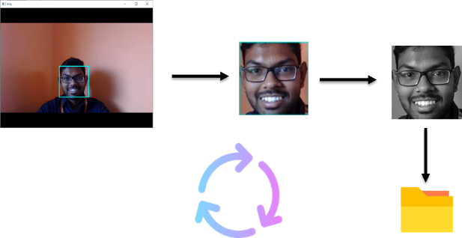

Fig 2 - Dataset Collection

4.1 Data Augmentation
Data Augmentation is a strategy that enables practitioners to significantly increase the diversity of data available for training models, without actually collecting huge data. It can be done by using techniques such as cropping, padding, and horizontal flipping are commonly used to train large neural networks. In order to achieve high accuracy, large volume of training data is required. Hence, data augmentation technique is used to generate new samples by manipulating the existing data. In the current work, synthetic images are being generated randomly, by applying the following operations:
- Zoom
- Shear
- Height shift
- Rotation
- Width shift

5. Developing CNN Model
The advancements in Computer Vision with Deep Learning has been constructed and perfected with time, primarily over one particular algorithm a Convolutional Neural Network. A Convolutional Neural Network (CNN) is a Deep Learning algorithm which can take in an input image, assign importance (learnable weights and biases) to various aspects/objects in the image and be able to differentiate one from the other.

5.1 Role of CNN in Computer Vision
Computer Vision is an interdisciplinary field of science that aims to make computers process, analyse images and videos and extract details in the same way a human mind does. Earlier computer vision was meant only to mimic human visual systems until we realized how AI can augment its applications and vice versa.
Convolutional Neural Networks has been playing a significant role in many applications including surveillance, object detection, object tracking, healthcare, retail, banking, automobile, financial services, etc. Extensive research is recorded for face recognition using CNNs, which is a key aspect of surveillance applications. The rise of deep learning has enabled Deep Neural Networks (DNN) to achieve greater results in pattern recognition and Convolutional Neural Network (CNN) is a class of DNN which is most commonly applied to analysing visual imagery. It is used not only in Computer Vision but also for text classification in Natural Language Processing (NLP).
CNNs performs well when compared to the feed forward neural networks as it uses less number of parameters for computation and also it uses different layers to learn the patterns. CNNs are used for a wide range of image-related tasks such as image classification, object detection/localization, image generation, visual question answering, image segmentation, etc. The availability of the computation power at a lower cost has enabled a path to solve a lot of problems which have been considered as virtually a hard task for the computers for the past few years.
Many architectures are created to solve computer vision tasks and some of the widely popular CNN architectures are AlexNet (2012), VGG-16 (2014), Inception-v1 (2014), Inception-v3 (2015), ResNet-50 (2015), Xception (2016), Inception-v4 (2016), Inception-ResNet-v2 (2016), ResNeXt-50 (2017).

5.2 Essential layers to develop CNN
The Convolutional Neural Networks CNNs have several different filters/kernels consisting of trainable parameters which can convolve on a given image spatially to detect features like edges and shapes. These high number of filters essentially learn to capture spatial features from the image based on the learned weights through back propagation and stacked layers of filters can be used to detect complex spatial shapes from the spatial features at every subsequent level. Hence they can successfully transform the given image into a highly abstracted representation which is easy for predicting.
There are different layers that are used in order to build an efficient CNN model. They are:
- Convolutional Layer
- Batch Normalization Layer
- Max Pooling Layer
- Dropout Layer
- Fully Connected Layer
Let’s see the in detailed explanation on the above mentioned layers that are used in order to build an efficient CNN model.

5.2.1 Convolution Layer
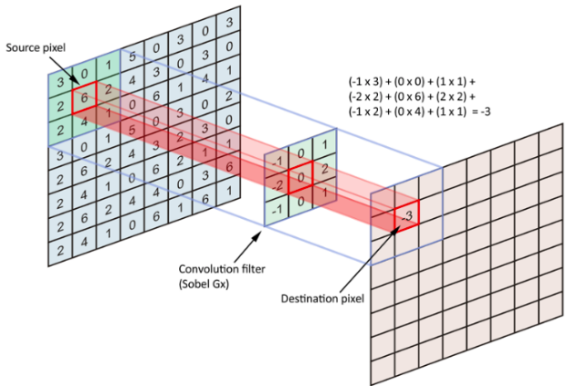

Fig 3 - Convolution layer
The objective of the Convolution Operation is to extract the high-level features such as edges, from the input image. CNNs need not be limited to only one Convolutional Layer. Conventionally, the first Convolutional Layer is responsible for capturing the Low-Level features such as edges, colour, gradient orientation, etc. With added layers, the architecture adapts to the High-Level features as well, giving us a network which has the wholesome understanding of images in the dataset, similar to how we would.

The above example illustrated the convolutional operation in 2D, but in reality convolutions are performed in 3D. Each image is namely represented as a 3D matrix with a dimension for width, height, and depth. Depth is a dimension because of the colours channels used in an image (RGB). Generally, numerous convolutions on the input is performed, where each operation uses a different filter. This results in different feature maps. In the end, we take all of these feature maps and put them together as the final output of the convolution layer.

5.2.2 Batch Normalization Layer

Training deep neural networks with tens of layers is challenging as they can be sensitive to the initial random weights and configuration of the learning algorithm. One possible reason for this difficulty is the distribution of the inputs to layers deep in the network may change after each mini-batch when the weights are updated. This can cause the learning algorithm to forever chase a moving target. This change in the distribution of inputs to layers in the network is referred to the technical name “internal covariate shift”.
Batch normalization is a technique for training very deep neural networks that standardizes the inputs to a layer for each mini-batch. This has the effect of stabilizing the learning process and dramatically reducing the number of training epochs required to train deep networks.

5.2.3 Max Pooling layer

Similar to the Convolutional Layer, the Pooling layer is responsible for reducing the spatial size of the convolved feature. This is to decrease the computational power required to process the data through dimensionality reduction. Furthermore, it is useful for extracting dominant features which are rotational and positional invariant, thus maintaining the process of effectively training of the model.
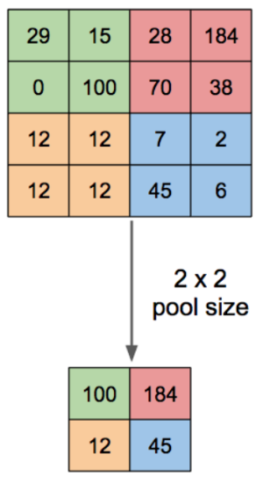
Max Pooling also performs as a Noise Suppressant. It discards the noisy activations altogether and also performs de-noising along with dimensionality reduction. The given figure illustrates the max pooling operation.

Fig 4 - Max Pooling Operations

5.2.4 Drop-out Layer

In machine learning, regularization is way to prevent over-fitting. Regularization reduces over-fitting by adding a penalty to the loss function. By adding this penalty, the model is trained such that it does not learn interdependent set of features weights. Dropout is an approach to regularization in neural networks which helps reducing interdependent learning amongst the neurons. It forces a neural network to learn more robust features that are useful in conjunction with many different random subsets of the other neurons. roughly doubles the number of iterations required to converge. However, training time for each epoch is less. The figure below illustrates the operation of dropout.
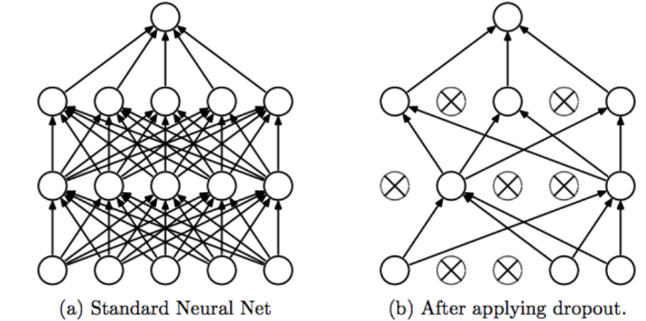

Fig 5 - Operation of Drop out

5.2.5 Fully Connected Layer

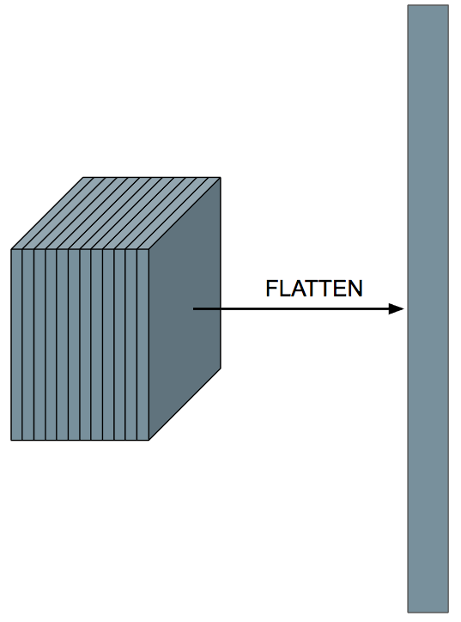
Adding a Fully-Connected layer is a (usually) cheap way of learning non-linear combinations of the high-level features as represented by the output of the convolutional layer. The Fully-Connected layer is learning a possibly non-linear function in that space. Now that we have converted our input image into a suitable form for our Multi-Level Perceptron, we shall flatten the image into a column vector. The flattened output is fed to a feed-forward neural network and backpropagation applied to every iteration of training. Over a series of epochs, the model is able to distinguish between dominating and certain low-level features in images and classify them using the softmax classification technique.

Fig 6 - Fully Connected Layer

6. Conclusion
In this paper, a face recognition and identification system is designed and developed using deep learning approach. The overall procedure of developing this face recognition system from training the data using CNN approach to face recognition is described. There are few factors that can affect the accuracy of the system. When the light intensity is insufficient, the accuracy is relatively low compared to higher light intensity. Other than that, classifier is the main element in the recognition process. The longer the classifier is trained, the better the classifier is performed. The images that are used to train the classifier must be in variety of conditions in order to generate a robust classifier. Face Recognition is one of the most widely used feature in many fields. It is used in providing security to data, Fraud detection of Passports and Visas, Track attendance, detecting the criminals etc. Computer vision models learn to model a task from a training set, however, like all deep learning models, they are prone to overfit the data they have been shown, making poor inferences in the wild. Occlusion techniques in computer vision block a portion of an image during training time, challenging the network to learn not to rely canonical features. Although systems have been developed for face detection and tracking, reliable face recognition still offers a great challenge to computer vision and pattern recognition researchers. There are several reasons for recent increased interest in face recognition, including rising public concern for security, the need for identity verification in the digital world, face analysis and modelling techniques in multimedia data management and computer entertainment

7. References

1] S. Albawi, T. A. Mohammed, and S. Al-Zawi, “Understanding of a convolutional neural network,” in 2017 International Conference on Engineering and Technology (ICET). IEEE, 2017, pp. 1–6.
[2] G. Hu, Y. Yang, D. Yi, J. Kittler, W. Christmas, S. Z. Li, and T. Hospedales, “When face recognition meets with deep learning: an evaluation of convolutional neural networks for face recognition,” in Proceedings of the IEEE international conference on computer vision workshops, 2015, pp. 142–150.
[3] J. Redmon, S. Divvala, R. Girshick, and A. Farhadi, “You only look once: Unified, real-time object detection,” in Proceedings of the IEEE conference on computer vision and pattern recognition, 2016, pp. 779–788.
[4] A. Khan, A. Sohail, U. Zahoora, and A. S. Qureshi, “A survey of the recent architectures of deep convolutional neural networks,” arXiv preprint arXiv:1901.06032, 2019.
[5] A. El-Sawy, E.-B. Hazem, and M. Loey, “Cnn for handwritten Arabic digits recognition based on lenet-5,” in International conference on advanced intelligent systems and informatics. Springer, 2016, pp. 566–575.
[6] Z.-W. Yuan and J. Zhang, “Feature extraction and image retrieval based on alexnet,” in Eighth International Conference on Digital Image Processing (ICDIP 2016), vol. 10033. International Society for Optics and Photonics, 2016, p. 100330E.
[7] H. Qassim, A. Verma, and D. Feinzimer, “Compressed residual-vgg16 cnn model for big data places image recognition,” in 2018 IEEE 8th Annual Computing and Communication Workshop and Conference (CCWC). IEEE, 2018, pp. 169–175.
[8] K. Sun, Q. Zhao, J. Zou, and X. Ma, “security system based on building video surveillance,” in International Conference on Smart City and Intelligent Building. Springer, 2018, pp. 153–162.
[9] M. Cos¸kun, A. Uc¸ar, O¨. Yildirim, and Y. Demir, “Face recognition based on convolutional neural network,” in 2017 International Conference on Modern Electrical and Energy Systems (MEES). IEEE, 2017, pp. 376–379.
[10] R. Fu, D. Wang, D. Li, and Z. Luo, “Face recognition system based on deep learning,” in 2017 10th International Conference on Intelligent Computation Technology and Automation (ICICTA). IEEE, 2017, pp. 128–131.

